This document describes steps to install Intel OpenVINO Toolkit and verify the installation.
Please make sure below system requirements are met before installing toolkit
Hardware
- 6th-8th Generation Intel® Core™
- Intel® Xeon® v5 family
- Intel® Xeon® v6 family
- Intel® Pentium® processor N4200/5, N3350/5, N3450/5 with Intel® HD Graphics

Processor Notes:
Processor graphics are not included in all processors. See Processor specifications for information about your processor.
A chipset that supports processor graphics is required if you're using an Intel Xeon processor. See Chipset specifications for information about your chipset.
Operating Systems
Ubuntu* 16.04 long-term support (LTS), 64-bit
Download OpenVINO for Linux
Download the latest version of OpenVINO for Linux by navigating to below link
https://software.intel.com/en-us/openvino-toolkit/choose-download/free-download-linux

Install external software dependencies
Open the terminal and go to the directory in which you downloaded the Intel® Distribution of OpenVINO™ toolkit.
This document assumes this is your ~/Downloads directory. If not, replace ~/Downloads with the directory where the file is located. By default, the package file is saved as l_openvino_toolkit_p_<version>.tgz
$Cd ~/Downloads
Unpack the .tgz file you downloaded:
$tar -zxf l_openvino_toolkit_p_<version>.tgz
The files are unpacked to a directory named l_openvino_toolkit_p_<version>.
Go to the l_openvino_toolkit_p_<version> directory:
$cd l_openvino_toolkit_p_<version>
Run a script to automatically download and install external software dependencies. These dependencies are required for the Intel-optimized version of OpenCV, the Deep Learning Inference Engine, and the Deep Learning Model Optimizer tools. Install these before the Intel Distribution of OpenVINO toolkit:
$sudo -E ./install_cv_sdk_dependencies.sh
As an option, you can install all the dependencies manually instead of running install_cv_sdk_dependencies.sh. In this case, use the list of dependencies at System Requirements.
Install the Intel® Distribution of OpenVINO™ toolkit core components
If you have a previous version of the toolkit installed, rename or delete two directories:
$/home/<user>/inference_engine_samples
$/home/<user>/openvino_models
To install the OpenVINO™ core components choose one of the installation options below and run the related script with root or regular user privileges. The default installation directory path depends on the privileges you choose for the installation.
You can use either a GUI installation wizard or command-line instructions. The only difference between the two options is that the command-line instructions are text-based. This means that instead of clicking options in a GUI, command-line prompts ask for input on a text screen.
GUI Installation Wizard:
$sudo ./install_GUI.sh

Follow the instructions on your screen. Watch for informational messages such as the following in case you must complete additional steps:
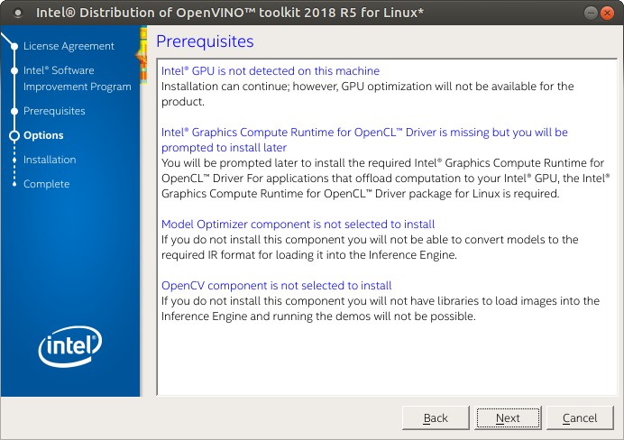
Click Next.
The Installation summary screen shows you the default component set to install:
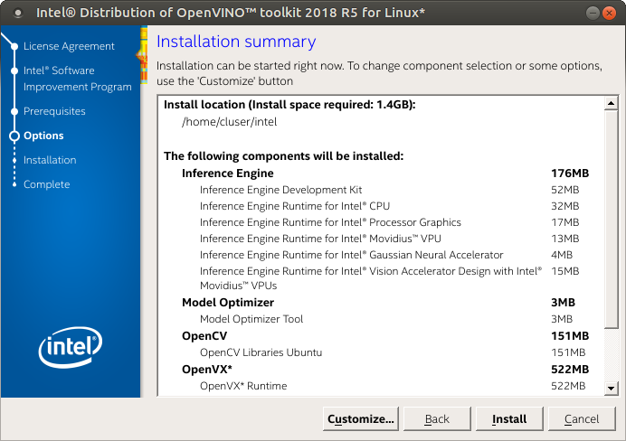
If you used root privileges to run the installer, it installs the Intel Distribution of OpenVINO toolkit in this directory: /opt/intel/computer_vision_sdk_<version>/
For simplicity, a symbolic link to the latest installation is also created: /opt/intel/computer_vision_sdk/
If you used regular user privileges to run the installer, it installs the Intel Distribution of OpenVINO toolkit in this directory: /home/<user>/intel/computer_vision_sdk_<version>/
For simplicity, a symbolic link to the latest installation is also created: /home/<user>/intel/computer_vision_sdk/
If needed, click Customize to change the installation directory or the components you want to install:
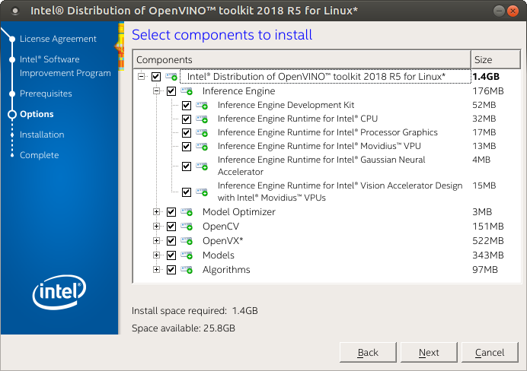
Click Next to save the installation options and show the Installation summary screen.
On the Installation summary screen, press Install to begin the installation.
When the first part of installation is complete, the final screen informs you that the core components have been installed and additional steps still required:
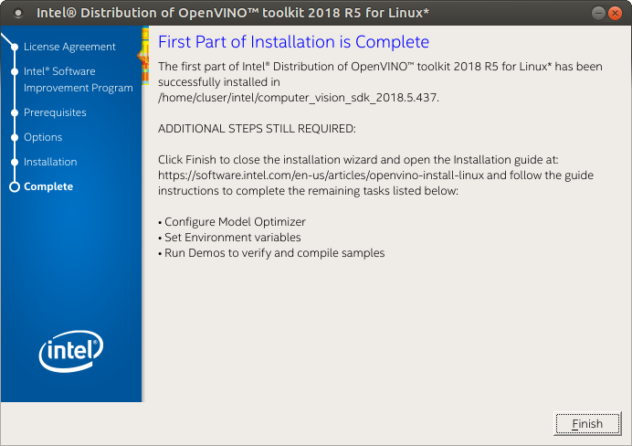
Click Finish to close the installation wizard. A new browser window opens to the next section of the installation guide to set the environment variables. You are in the same document. The new window opens in case you ran the installation without first opening this installation guide.
The core components are installed. Continue to the next section to set environment variables.
Set the environment variables
You must update several environment variables before you can compile and run OpenVINO™ applications. Run the following script to temporarily set your environment variables:
$source /opt/intel/computer_vision_sdk/bin/setupvars.sh
(Optional) The Intel Distribution of OpenVINO toolkit environment variables are removed when you close the shell. As an option, you can permanently set the environment variables as follows:
Open the .bashrc file in <user_directory>:
~/.bashrc
Add this line to the end of the file:
source /opt/intel/computer_vision_sdk/bin/setupvars.sh
Save and close the file: press the Esc key and type :wq.
To test your change, open a new terminal. You will see
[setupvars.sh] OpenVINO environment initialized.
The environment variables are set. Follow next section to configure the Model Optimizer.
Configure the Model Optimizer
Important: This section is required. You must configure the Model Optimizer for at least one framework. The Model Optimizer will fail if you do not complete the steps in this section.
The Model Optimizer is a key component of the Intel Distribution of OpenVINO toolkit. You cannot do inference on your trained model without running the model through the Model Optimizer. When you run a pre-trained model through the Model Optimizer, your output is an Intermediate Representation (IR) of the network. The IR is a pair of files that describe the whole model:
Model Optimizer configuration steps
You can either configure the Model Optimizer for all supported frameworks at once, or for one framework at a time. Choose the option that best suits your needs. If you see error messages, make sure you installed all dependencies.
Note: If you did not install the Intel Distribution of OpenVINO toolkit to the default installation directory, replace /intel/ with the directory where you installed the software to.
Configure the Model Optimizer for each framework separately:
Go to the Model Optimizer prerequisites directory:
$Cd /opt/intel/computer_vision_sdk/deployment_tools/model_optimizer/install_prerequisites
Run the script for your model framework. You can run more than one script:
For Caffe:
$sudo ./install_prerequisites_caffe.sh
For TensorFlow:
$sudo ./install_prerequisites_tf.sh
The Model Optimizer is configured for one or more frameworks. You are ready to use two short demos to see the results of running the Intel Distribution of OpenVINO toolkit and to verify your installation was successful. The demo scripts are required since they perform additional configuration steps. Continue to the next section.
Use the Demo Scripts to Verify Your Installation
Go to the Inference Engine demo directory:
$cd /opt/intel/computer_vision_sdk/deployment_tools/demo
Run the Image Classification demo:
$./demo_squeezenet_download_convert_run.sh
The Image Classification demo uses the Model Optimizer to convert a SqueezeNet model to .bin and .xml Intermediate Representation (IR) files. The Inference Engine component uses these files.
This demo uses car.png in the demo directory. When the demo completes, you will see the label and confidence for the top-10 categories: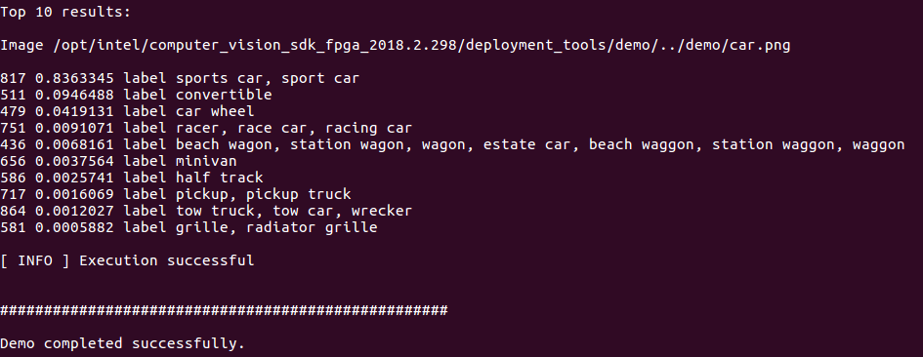
References
https://software.intel.com/en-us/articles/OpenVINO-Install-Linux#Optional-steps

